Prof. Hefziba Lifshitz  Machado Chair for Research on Cognitive modifiability and the Development of Intelligence  Head of Empowerment project  Director: Dr. Shoshana Nissim | Faculty of Social Sciences  School of Education  MA program in ID

Baker Research Center
Enhancement, Research and Inclusion of Children with Intellectual Disability in the Society
Head: Prof. Hefziba Lifshitz
Director: Dr. Varda Rozental-Sobelman
Founder: Prof. Pnina Klein

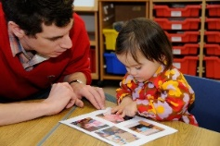
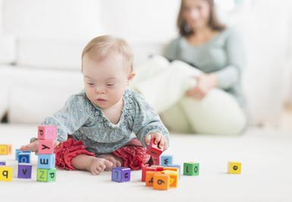

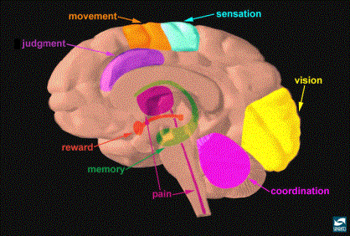
CAB – Cognition, Affect, Behavior –
the MISC Model (Klein, 2003)

